*Synapse Quantification (SynQuant)*

Introduction

SynQuant is a Fiji plugin that automatically quantify synapses from multi-channel fluorescence microscopy image. Both synapse and corresponding dendrite are detected. Synapses are detected on synapse channel, where they act as puncta surrounded by highly inhomogeneous interference signals. Dendrite is extracted from the reference dendrite channel.

SynQuant detect synapses through a totally unsupervised probability principled framework. In this framework, analysis is conducted on salient regions rather than pixels. All synapse candidates are scored by their own local contrast and compared fairly with each other. What’s more, false discover rate (FDR) control is utilized to determine synapse selection, which not only controls the false positive rate but also provides a statistical evidence of the detected synapse. The parameter used in this framework is only the value of FDR which is easy to tune. SynQuant extract dendrite by steerable filter [1]. Extracted dendrite then are segmented into roughly homogeneous pieces by branch points and end points. Based on the dendrite pieces and synapses, linear regression is used to find the effects of dendrite’s properties to the number of synapses on it.

Functions Supported

SynQuant could not only quantify synapses, but also some related tasks on both 2D and 3D microscopy images. Now SynQuant could totally support 6 functions including **“Pre-synaptic puncta detection”, “Post-synaptic puncta detection”, “Dendrite detection”, “Synapse quantification”, “Synaptic site detection”, and “Synaptic site quantification”**. (SynQuant now does not support dendrite extraction on 3D data because we did not find suitable benchmark.) The details of these functions can be found in the “**Outputs**” section.

How to cite

Yizhi Wang, Congchao Wang, Petter Ranefall, Gerard Broussard, Yinxue Wang, Guilai Shi, Yue Wang, Lin Tian, Guoqiang Yu, *SynQuant: An Automatic Tool to Quantify Synapses from Microscopy Images*, BioRxiv 538769; doi: <https://doi.org/10.1101/538769>

Tutorial

***Installation***

Download file “SynQuantVid_-*.*.jar” (*.* means version number) from “<https://github.com/yu-lab-vt/SynQuant/releases>”. To install the SynQuant plugin, simply save the jar file to the folder “\Fiji.app\plugins\” and call “Help=>Refresh Menus” or restart Fiji/ImageJ. The SynQuant plugin will be available in Fiji/ImageJ’s “Plugins” menu.

Some functions of SynQuant plugin are based on Apache Commons Math, which is supported from Fiji version (1.50d). Also you can download the “commons-math*-*-bin.zip” from “<https://commons.apache.org/proper/commons-math/download_math.cgi>” and save the “commons-math*-*.jar” to the same file as “SynQuantVid_.jar”.

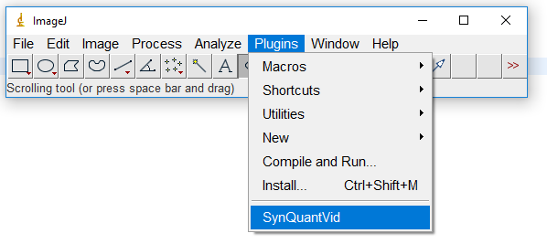

Figure . Start SynQuant

The plugin has been tested and successfully run on ImageJ version 1.50d. If users encounter problems using older version of ImageJ, please update your ImageJ to the newer version.

***Input***

SynQuant is designed to handle 8-bit or 16-bit grayscale image. User can use Fiji/ImageJ’s “Image\Type\8-bit (or 16-bit)” to first change the data into these formats and then call SynQuant. If the image contains multiple channels, user need to separate them using “Image\Color\Split Channels”: (pre-synaptic or post-synaptic) for synapse detection and dendrite channel for dendrite extraction. It also could handle single channel 8-bit or 16-bit grayscale image for one of the two tasks.

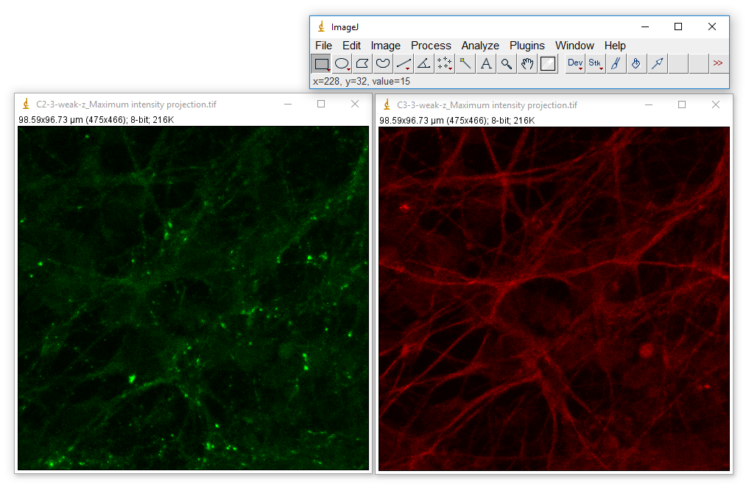

Figure . Open test data. Left: synapse channel, right: dendrite channel

***Parameter setting***

We have five parameters.

Z-score for Particle Detection: The lowest z-score that puncta can have. If z-score threshold is 0, we will use fdr control with q-value 0.05 to get the proper z-score threshold.

Min/Max Particle Size: The size interval of possible synapses. With the grayscale image.

Min fill: The size of the detected punctum divided by the size of its bounding box.

Max WH Ratio: The scale ratio of a punctum’s bounding box. It is the smaller value of the width divided by the height or the height divided by the width.

“Min fill” and “Max WH Ratio” together are used to control the shape convexity of the puncta.

run SynQuant from the Plugins menu. A dialogue will show and ask user to input the parameters as is shown below. The first five parameters are explained as before. Suggested value is given as default in the textboxes. The last three popup menus are to specify pre-synaptic, post-synaptic and dendrite data. If user only wants to do synapse (pre- or post-) detection or dendrite extraction, leave others as null. After setting the parameters, click “OK”. The running time is decided by the image size. Both 2D and 3D data are supported for synapse detection. For dendrite extraction, only 2d data is supported.

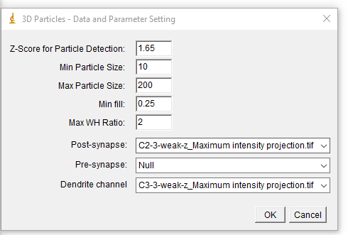

Figure . Parameter input

***Supported functions***

Based on the image data user inputs, SynQuant could fulfill totally 6 functions related to synapse quantification. Based on the input image data:

If only input Post-synapse or Pre-synapse data, synapse detection is done on the input images. If input both Post-synapse and Pre-synapse data, detection results on these two data will be combined together. If the Dendrite channel is also provided, synapse will be quantified based on the dendrite properties. For example, if user would like to do synapse quantification, she/he needs to provide at least one synaptic image data and dendrite image data.

***Outputs***

The outputs vary across functions. In the following paragraphs, we will illustrate the different outputs of different functions.

**F1&F2. Pre-synaptic puncta detection** and **Post-synaptic puncta detection**

For synapse detection, user will get a colorful output image, which is the combination of detected synaptic puncta and original synapse channel. We also provide a slider for user to tune the results with new z-score threshold (Fig. 4). The pre-synaptic puncta (or post-synaptic puncta) are marked out by bright color. After setting the final z-score threshold and click OK. The detected puncta will be recorded in the ROI Manager as is shown on the right side in Figure 5. User could show the labeled synaptic puncta by check the “Labels” checkbox in the ROI Manager Dialog as is shown in Figure 6. By clicking “Measure” button, all puncta’s size, mean, minimize and maximize intensity values can be got and saved as is shown in Figure 6. User can also save all puncta information by clicking “More >> 🡺 save…” in the ROI Manager Dialogue.

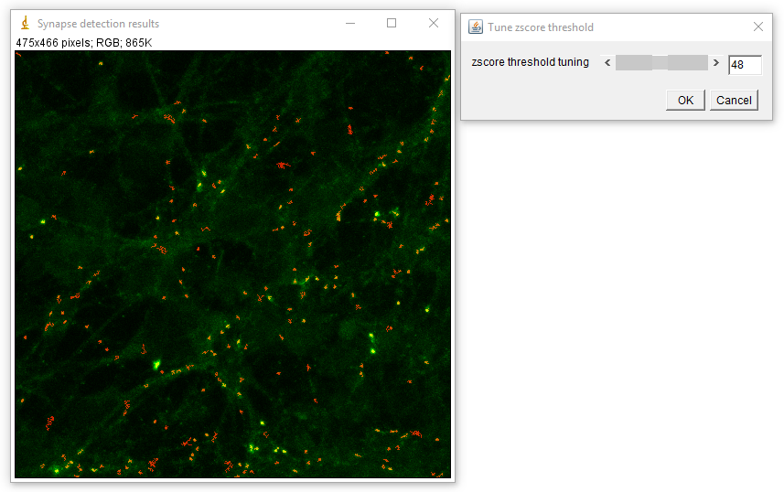

Figure 4. Synaptic puncta detection result

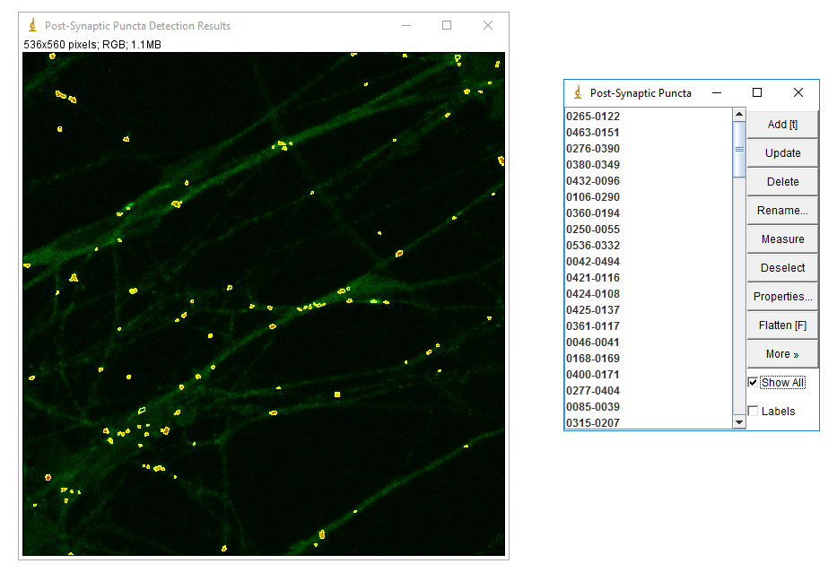

Figure 5. Synaptic puncta detection result

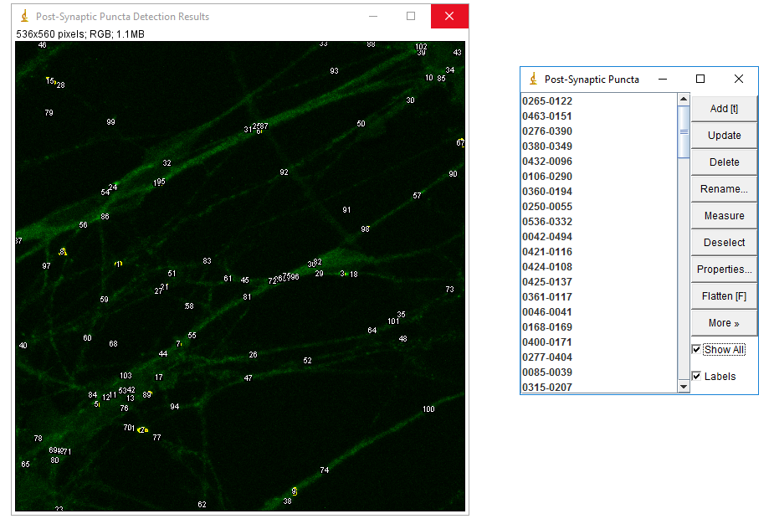

Figure 6. Synaptic puncta detection result with roi labels

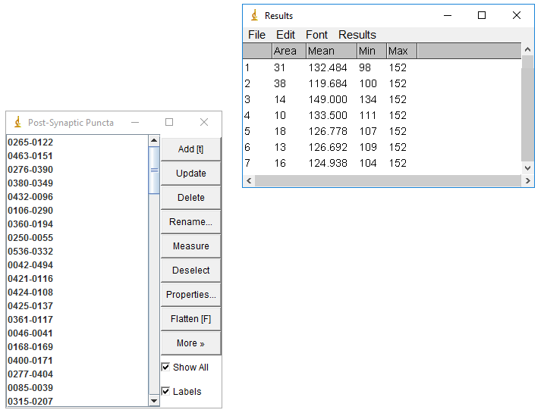

Figure 7. Puncta properties using Measure in ROI Manager.

**F3. Dendrite detection**

For dendrite detection, user will get a colorful output image which is combination of extracted dendrite and original dendrite channel. All extracted dendrite is marked as brown. As most dendrite are connected, it is hard to define ROI on this output. So we use a table to show user the dendrite length as Figure 9. User can use “File\save” to save the dendrite mask. If user would like to save the binary dendrite mask only, she/he could use “Image🡺Color🡺Split Channels” to get the three channels of the output image as is shown in Figure 10. The green and blue channel are what is needed. (The synapse mask can also be got using this way.)

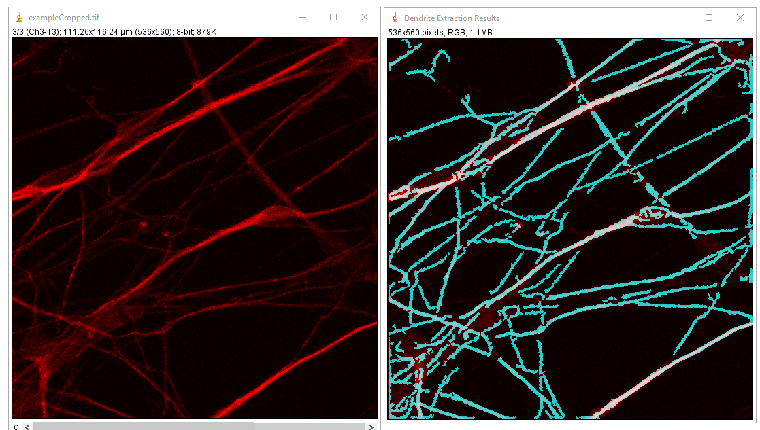

Figure 8. Dendrite detection result

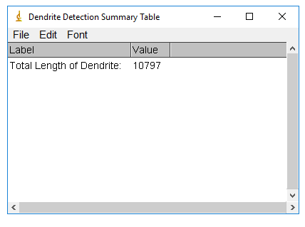

Figure 9. Dendrite length table

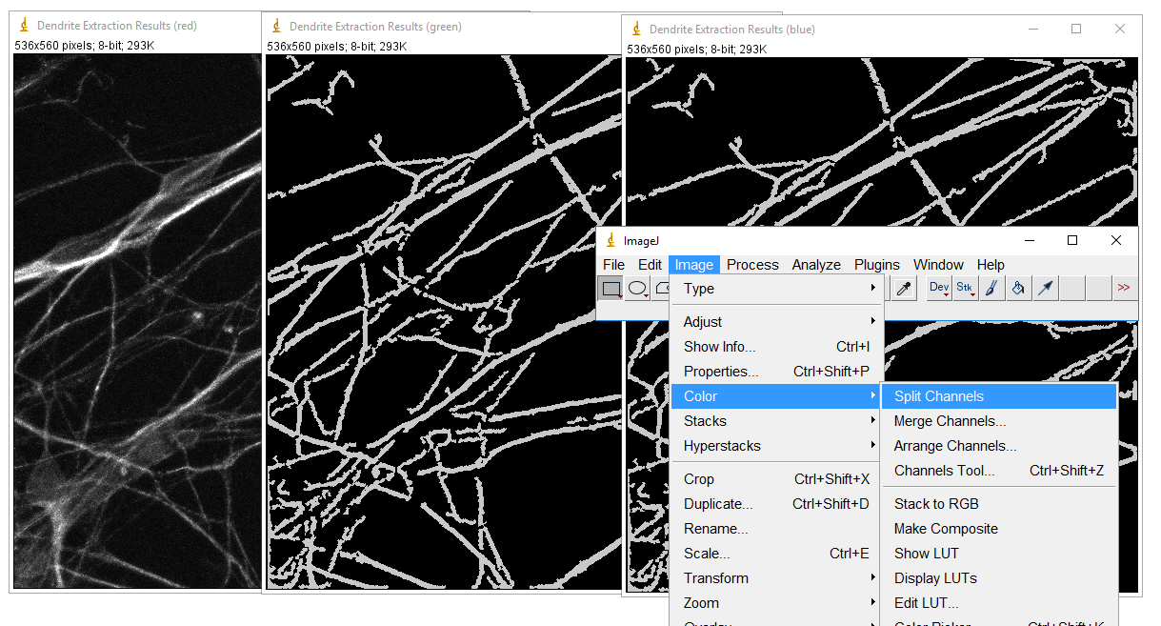

Figure 10. Channel split to get dendrite mask

**F4.** **Synapse quantification**

For synapse quantification, all the outputs in F1, F2 and F3 will also be shown. Besides, the quantification step will output three more tables.

The first one is “Feature Table” as is shown in Figure 11. All dendrites are segmented into small homogeneous pieces and for each piece, we collect its length, scale and mean intensity as its properties. Because each detected synapse is assigned to its nearest dendrite piece, each dendrite piece also has a property that indicates how many synapses related to it.

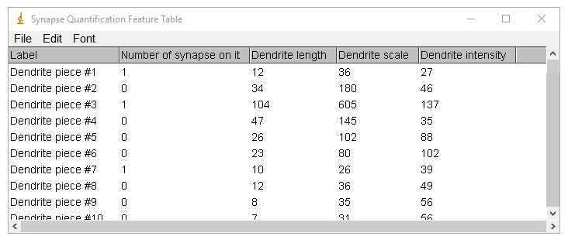

Figure 11. Synapse Quantification Feature Table

The second table is to illustrate the effects of the three dendrite features to the number of synapses grow on this dendrite piece. The values are the corresponding coefficients got through generalized linear model (Poisson regression).

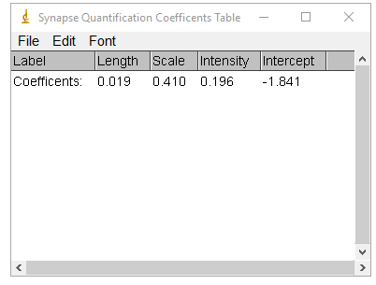

Figure 12. Relationships between synapse number and dendrite features

The third table is a summery table including the total number of detected synapse puncta, total length of dendrite, and puncta density per unit length as is shown in Figure 12.

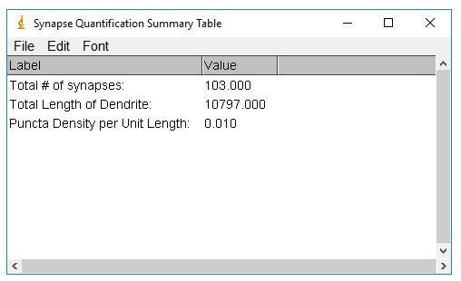

Figure 13. Summery table for synapse quantification

**F5. Synaptic site detection**

Often, researchers want to compare locations of pre- and post-synaptic puncta (i.e., indicating the position of true synaptic sites). Therefore, we allow user to detect pre- and post- synaptic puncta at the same time and based on the detection results, generate the overlap of pre- and post-synaptic puncta. This is automatically done if user provides both pre- and post-synaptic images.

The overlapped regions are shown in Figure 14. This output is just like that in F1 and F2. User can output the ROIs using ROI Manager.

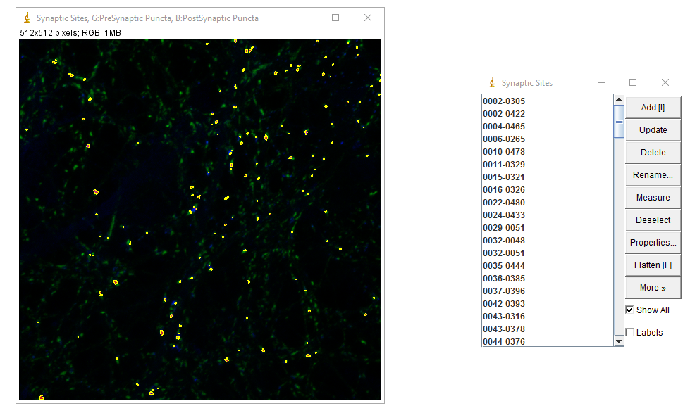

Figure . Overlapped puncta detection result

**F6. Synaptic site quantification**

Synaptic site quantification is similar with synapse quantification which only changes the dependent variable from number of synapses on one dendrite piece to the number of synaptic sites on one dendrite piece. The outputs of F6 is the same F4 (synapse quantification).

If you have any question, please contact [ccwang@vt.edu](mailto:ccwang@vt.edu).

1. Meijering E, Jacob M, Sarria J, Steiner P, Hirling H, Unser M. Design and valida-tion of a tool for neurite tracing and analysis in fluorescence microscopy im-ages. Cytometry A 2004;58:167–76.